

***V4.1***

**5/7/2015**

Design Document

**JUDGE FROG**

# Revision History

|  |  |  |
| --- | --- | --- |
| Version | Changes | Edited |
| 1.0 | * Initial Draft | November 25, 2014 |
| 1.1 | * Database Schema Updated * Modified Development Environment | January 16, 2015 |
| 2.0 | * Updated Prototypes * Updated Database schema | February 15, 2015 |
| 2.1 | * Updated Glossary of Terms * Updated Prototypes * Updated Database description | February 16, 2015 |
| 2.2 | * Database Hierarchy Model Added * Database Table Descriptions Updated * Data Flow Model Added | February 19, 2015 |
| 3.0 | * Updated database tables, prototypes, glossary | April 26, 2015 |
| 4.0 | * Fixed fonts * Changed Database section | May, 4 2015 |
| 4.1 | * Fixed fonts again * Fixed Table of Contents | May 7, 2015 |

# Revision Sign-Off

By signing the following, the team member is stating that he has read the entire document and has concluded that the information contained within this document is accurate, relevant to the project, and void of errors.

|  |  |  |
| --- | --- | --- |
| Name | Signature | Date Signed |
| Brice Boula |  |  |
| Collin Duncan |  |  |
| David Tomlinson |  |  |
| Landon Westrom |  |  |

# Table of Contents

Revision History ii

Revision Sign-Off iii

Table of Contents iv

1. Introduction 1

1.1 Purpose 1

1.2 Project Background 1

1.3 Section Overview 1

2. Design Constraints 2

2.1 Assumptions and Dependencies 2

2.2 General Constraints 2

2.3 Development Environment 3

3. Data Flow 4

3.1 Database 5

3.2 Web Application 5

4. Database Design 6

4.1 Database Tables 7

5. UML Models 12

5.1 Sequence Diagrams 12

5.1.1 Admin Create Sequence 12

5.1.2 Admin Edit Sequence 13

5.1.3 Admin Delete Sequence 14

5.1.4 Admin Uploads Sequence 15

6. User Interface Prototype 16

6.1 Search Interface 16

6.2 Analyze 17

6.3 Admin Panel 18

7. Glossary of Terms 25

# Introduction

## Purpose

This document provides a complete description of the Judge Frog system design. Included in this document are design constraints, system architecture, user interface design, and Unified Modeling Language (UML) diagrams (state, class, and sequence).

## 1.2 Project Background

Judge Frog is designed to be a fully functional web application with a user-friendly user interface. The application shall provide an efficient database containing significant human trafficking data inserted by the client. The end user shall be presented with visual graphs and charts to sort and analyze the data using various filters. Concluding the user’s data analysis, the user shall have the option of exporting the visual data.

## 1.3 Section Overview

**Section 2 – Design Constraints**: Describes assumptions and dependencies, general constraints, and developmental methods for the Judge Frog web application.

**Section 3 – System Architecture**: Displays a model of the architecture and major component descriptions.

**Section 4 – Database Design**: Models the design of the database and describes the attributes of each table in the database.

**Section 5 – UML Models**: Displays the state, class and sequence diagrams.

**Section 6** **–** **User Interface**: Gives screenshots from the prototype of the smartphone application.

**Section 7 – Glossary of Terms**: Defines technical and project-specific terms used in this document.

# Design Constraints

## 2.1 Assumptions and Dependencies

The Judge Frog Web application will assume the following:

* The user shall access the Web application from a desktop computer
* The user can use the Web application after instruction

## 2.2 General Constraints

* Time
  + Development must be completed by the end of the school year in May 2015.
* Data storage
  + Finite amount of storage space on server used for storage
* Communication
  + Requires continuous Internet access to use the application
* Browser
  + Internet Explorer version 9 or higher
  + Google Chrome version 40 or higher
  + Mozilla Firefox version 33 or higher
  + Safari version 5 or higher

## 2.3 Development Environment

**Programming Utilities**

* MySQLWorkbench 6.2 CE
* PHP 5.5
* CakePHP 2.5.1
* GitHub
* phpMyAdmin 4.0.4.2
* MySQL 5.6.14
* Apache 2.2
* Bootstrap 3.1.1

**General Utilities**

* Microsoft Word
* Microsoft PowerPoint
* Google Drive
* Notepad++ 6.7.4
* Sublime Text Editor 2
* CoreFTP 2.2

# Data Flow



## Database

Our database stores human trafficking data collected by the National Institute of Justice. The well-designed database is stored on our server to be interacted with the web application. The database is developed with the Extended Entity-Relationship model using MySQL Workbench.

## Web Application

The developed Web application connects to the database to insert and retrieve human trafficking data to create analysis for the user. The Web application provides a detailed tutorial on the functionality and navigation present in the application. There is a separate portal for administrative access to database functions.

# Database Design

The diagram below shows a screenshot of the MySQL workbench as it views the models. Below this is a description of all of the columns included in the models for reference.

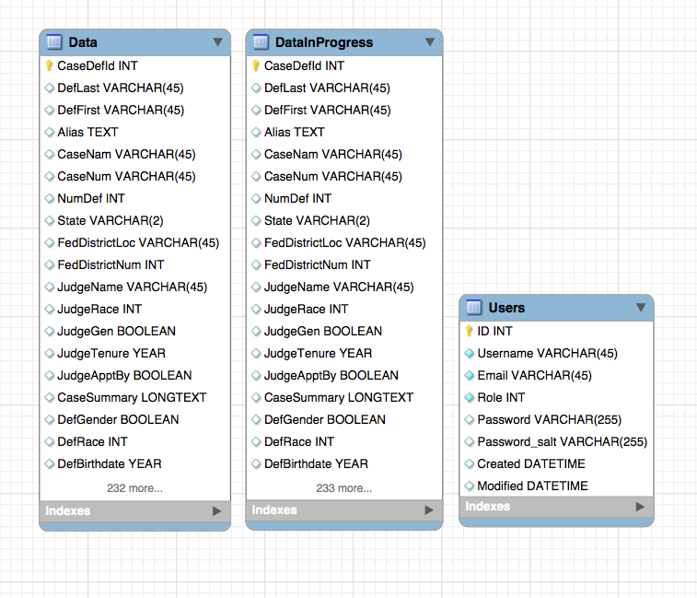

## 4.1 Database Tables

The **schema** for the **MySQL database** used in the current version of this project will be represented below in a table showing the: **name**, **type**, **attributes**, **default**, and **description** of each **column** for each **table** in the **database**. The **attributes** column will contain abbreviations which correspond to **MySQL Workbench** abbreviations: **PK** is **primary** **key**; **NN** is **not** **null**, **UQ** is **unique**, **BIN** is **binary**, **UN** is **unsigned**, **ZF** is **zero-fill**, **AI** is **auto-increment** (<http://dev.mysql.com/doc/workbench/en/wb-table-editor-columns-tab.html>).

**Users table:**

|  |  |  |  |  |
| --- | --- | --- | --- | --- |
| Name | Type | Attributes | Default | Description |
| Id | INTEGER | PK, NN, UQ, AI |  | ID given to each user to uniquely identify them. |
| Username | VARCHAR(45) | NN, UQ |  | Username for the given user. |
| Email | VARCHAR(45) | NN |  | Email address for the given user. |
| Role | VARCHAR(16) | NN | ‘ra’ | The role of the given user. The value ‘admin’ gives the user administrative permissions and any other value gives them research assistant permissions. |
| Password | VARCHAR(255) | NN |  | Salted and hashed password for the given user. |
| Created | DATETIME |  |  | Timestamp of when the user was created. |
| Modified | DATETIME |  | Null | Timestamp of when the user was modified. |
| First_name | VARCHAR(45) |  |  | First name of the user. |
| Last_name | VARCHAR(45) |  |  | Last name of the user. |

**Data table:**

The value ‘[statute]’ in the **Data** table represents a value for one of the recognized statutes within our application. These statutes are: 1961 – 1968, 1028, 1351, 1425, 1512, 1546, 1581 – 1588, 1589, 1590, 1591, 1592, 2252, 2260, 2421 – 2424, 1324, and 1328. They are also listed in more detail on our website: <http://humantraffickingdata.org/description> (under Statutes tab).

|  |  |  |  |
| --- | --- | --- | --- |
| Name | Type | Attributes | Description |
| Id | INTEGER | PK, NN, AI | ID given to each record to uniquely identify it. |
| Author | VARCHAR(45) | NN | User who published this record. |
| Created | DATETIME |  | Timestamp of when the record was published. |
| Modified | DATETIME |  | Timestamp of when the record was last modified. |
| CaseDefId | INTEGER |  |  |
| CaseNam | VARCHAR(45) |  | The official name of the case. |
| CaseNum | VARCHAR(45) |  | The official number of the case. |
| NumDef | INTEGER |  | The total number of defendants in this case. |
| State | VARCHAR(2) |  | The state in which the case was held. |
| FedDistrictLoc | VARCHAR(45) |  | The location within the federal district (North, Central, South, etc.) |
| FedDistrictNum | INTEGER |  | The number of the federal district where this case was located (1-13). |
| JudgeName | VARCHAR(45) |  | The name of the last judge involved in the case. |
| JudgeRace | INTEGER |  | The race of the last judge involved in the case.  The values are as defined: 0 is white; 1 is black; 2 is Hispanic; 3 is Asian; 4 is Indian. |
| JudgeGen | BOOLEAN |  | The gender of the last judge involved in the case. True corresponds with female and false corresponds with male. |
| JudgeTenure | YEAR |  | The tenure of the last judge involved in the case. |
| JudgeApptBy | BOOLEAN |  | The political party who appointed the judge. True corresponds with Democrat and false corresponds with Republican. |
| CaseSummary | LONGTEXT |  | A summary of the case. |
| DefLast | VARCHAR(45) | NN | The last name of this defendant. |
| DefFirst | VARCHAR(45) | NN | The first name of this defendant. |
| Alias | TEXT |  | A list of aliases of the defendant separated by ‘;’. |
| DefGender | BOOLEAN |  | The gender of the defender. True designates female and false designates male. |
| DefRace | INTEGER |  | The race of the defendant. 0 represents white; 1 represents black; 2 represents Hispanic; 3 represents Asian; 4 represents other. |
| DefBirthdate | YEAR | NN | The year of the defendant’s birth. |
| DefArrestAge | INTEGER |  | The age at arrest of the defendant. |
| ChargeDate | DATE |  | The date the defendant was charged. |
| ArrestDate | DATE |  | The date the defendant was arrested. |
| Detained | BOOLEAN |  | Value representing whether defendant was detained. |
| BailType | INTEGER |  | The type of bail given to defendant. 0 represents none, 1 represents surety, 2 represents non-surety. |
| BailAmount | DOUBLE |  | The amount of bail to be paid by the defendant. |
| LaborTraf | BOOLEAN |  | Value representing whether this case contained labor trafficking charges. |
| AdultSexTraf | BOOLEAN |  | Value representing whether this case contained adult sex trafficking charges. |
| MinorSexTraf | BOOLEAN |  | Value representing whether this case contained minor sex trafficking charges. |
| FelCharged | INTEGER |  | The total number of felonies charged against the defendant. |
| FelSentenced | INTEGER |  | The total number of felonies sentenced against the defendants. |
| S[statute] | BOOLEAN |  | Value representing whether this particular statute, [statute], was charged in the given case for this defendant. |
| Counts[statute] | INTEGER |  | Number of counts charged against defendant for this particular statute. |
| CountsNP[statute] | INTEGER |  | Number of counts nolle prossed for this defendant for this particular statute. |
| PleaDismissed[statute] | INTEGER |  | Number of pleas dismissed for this defendant for this particular statute. |
| PleaGuilty[statute] | INTEGER |  | Number of times plead guilty for this defendant for this particular statute. |
| TrialGuilty[statute] | INTEGER |  | Number of trials found guilty for this defendant for this particular statute. |
| TrialNG[statute] | INTEGER |  | Number of trials found not guilty for this defendant for this particular statute. |
| Fines[statute] | INTEGER |  | Amount of fines levied against defendant for this particular statute. |
| Sent[statute] | INTEGER |  | Number of months sentenced against this defendant for this particular statute. |
| Prob[statute] | INTEGER |  | Number of months of probation required for this defendant for this particular statute. |
| DateTerm | DATE |  | The date when the sentence was terminated. |
| SentDate | DATE |  | The date when the sentencing began. |
| TotalSentence | INTEGER |  | The total number of months sentenced for this defendant. |
| Restitution | DOUBLE |  | The amount of restitution required to pay by the defendant. |
| AssetForfeit | BOOLEAN |  | Value representing whether the defendant had to forfeit various assets. |
| SupRelease | BOOLEAN |  | Value representing whether the defendant had supervised release. |
| Probation | INTEGER |  | The total number of months of probation required by this defendant. |
| NumVic | INTEGER |  | Total number of victims involved in this case. |
| NumVicMinor | INTEGER |  | Total number of minor victims involved in this case. |
| NumVicForeign | INTEGER |  | Total number of foreign victims involved in this case. |
| NumVicFemale | INTEGER |  | Total number of female victims involved in this case. |
| OCName1 | VARCHAR(45) |  | The name of the first organized crime group that this defendant was involved in. |
| OCType1 | INTEGER |  | The size of the first organized crime group that this defendant was involved in. 1 represents ‘Mom & Pop’, 2 represents ‘Street Gang’, 3 represents ‘Cartel/Syndicate/Mafia’, 5 represents ‘Prison Gang’, 6 represents ‘Other’. |
| OCRace1 | INTEGER |  | The race of the first organized crime group that this defendant was involved in. 0 represents ‘None’, 1 represents ‘Black’, 2 represents ‘White’, 3 represents ‘Hispanic’, 4 represents ‘Asian’, 5 represents ‘Other’. |
| OCScope1 | INTEGER |  | The scope of the first organized crime group that this defendant was involved in. 0 represents ‘Other’, 1 represents ‘Local Only’, 2 represents ‘Trans-State’, 3 represents ‘Trans-National’. |
| OCName2 | VARCHAR(45) |  | The size of the second organized crime group that this defendant was involved in. 1 represents ‘Mom & Pop’, 2 represents ‘Street Gang’, 3 represents ‘Cartel/Syndicate/Mafia’, 5 represents ‘Prison Gang’, 6 represents ‘Other’. |
| OCType2 | INTEGER |  | The race of the second organized crime group that this defendant was involved in. 0 represents ‘None’, 1 represents ‘Black’, 2 represents ‘White’, 3 represents ‘Hispanic’, 4 represents ‘Asian’, 5 represents ‘Other’. |
| OCRace2 | INTEGER |  | The scope of the second organized crime group that this defendant was involved in. 0 represents ‘Other’, 1 represents ‘Local Only’, 2 represents ‘Trans-State’, 3 represents ‘Trans-National’. |
| OCScope2 | INTEGER |  | The size of the second organized crime group that this defendant was involved in. 1 represents ‘Mom & Pop’, 2 represents ‘Street Gang’, 3 represents ‘Cartel/Syndicate/Mafia’, 5 represents ‘Prison Gang’, 6 represents ‘Other’. |

**DataInProgress table:**

The **DataInProgress** table features exactly the same information as the **Data** table. However, our client wanted to separate the data into two tables with one being for finalized information and one being for information still in progress. The only additional field in **DataInProgress** is:

|  |  |  |
| --- | --- | --- |
| Name | Type | Description |
| SubmittedForReview | BOOLEAN | If true, this case will be displayed for administrators to publish to **Data**. If false, the case is still being revised. |

# UML Models

## 5.1 Sequence Diagrams

### 5.1.1 Admin Create Sequence



### 5.1.2 Admin Edit Sequence



### 5.1.3 Admin Delete Sequence



### 5.1.4 Admin Uploads Sequence



# User Interface Prototype

## 6.1 Search Interface

## U:\pics\search2.PNGU:\pics\search3.PNGU:\pics\search1.PNG

## 6.2 Analyze

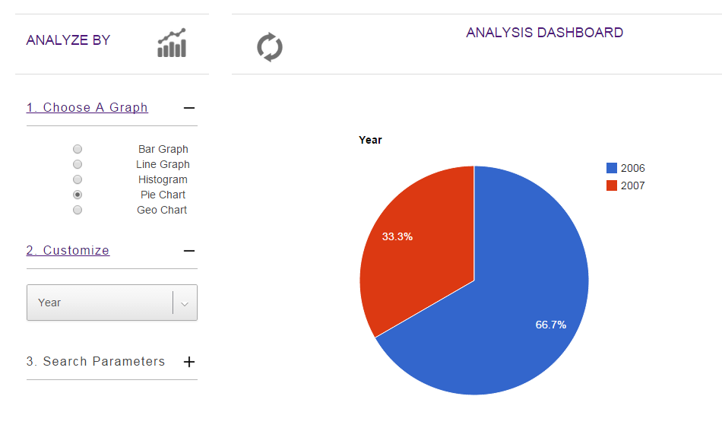

## 6.3 Admin Panel

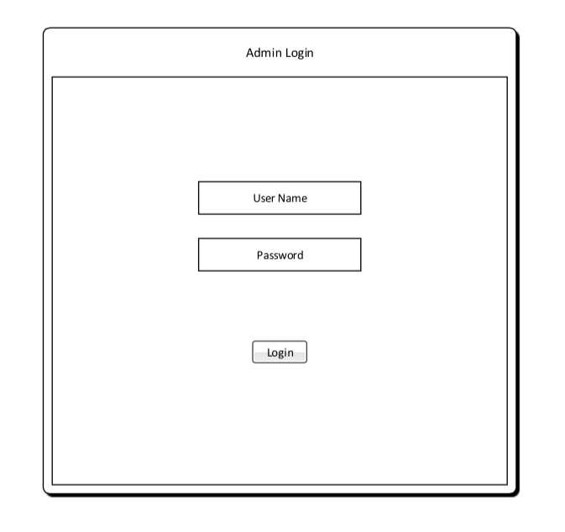

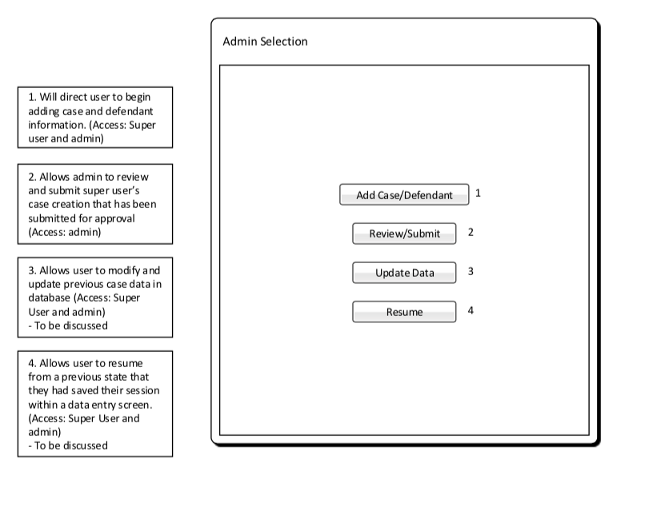

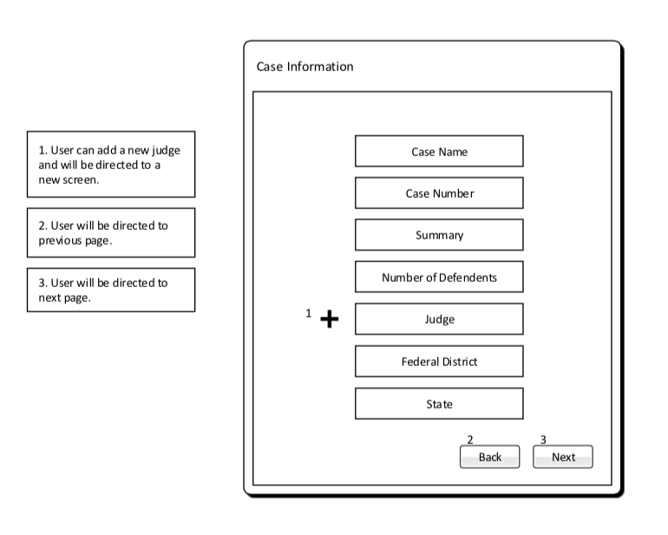

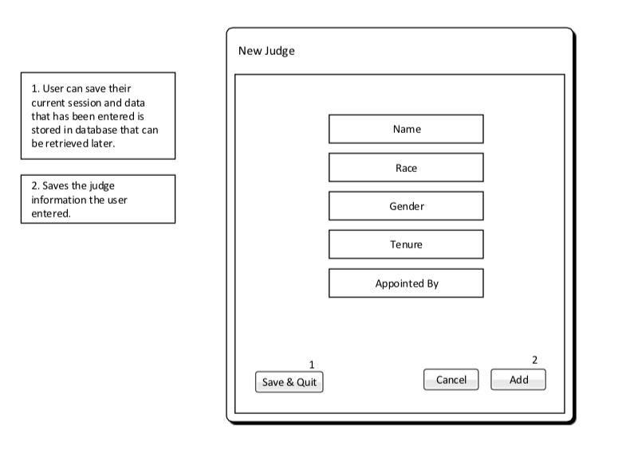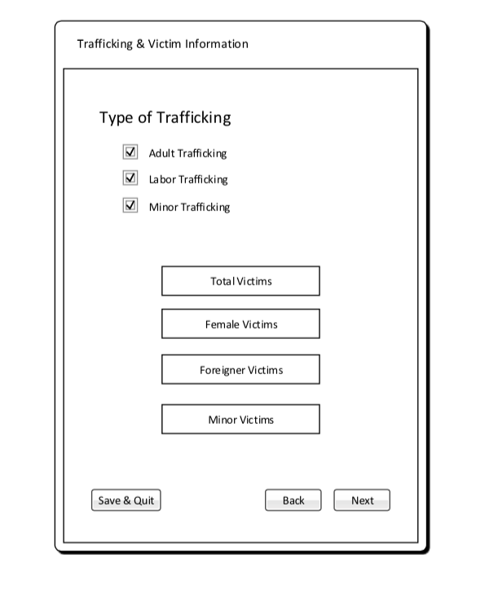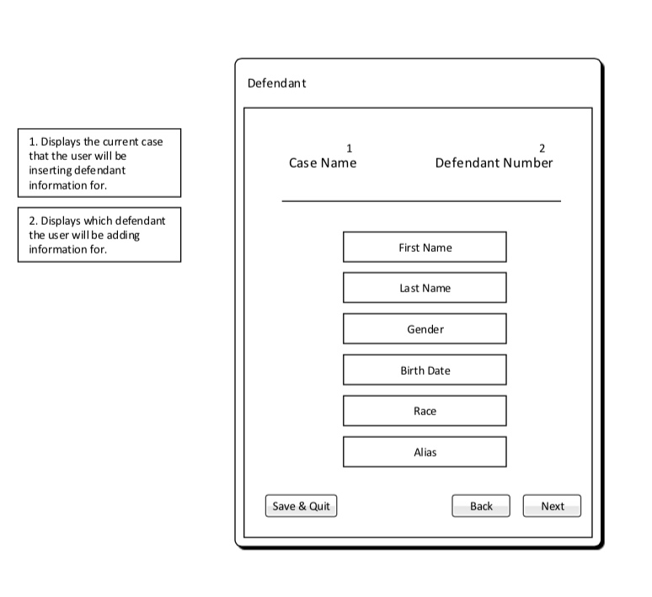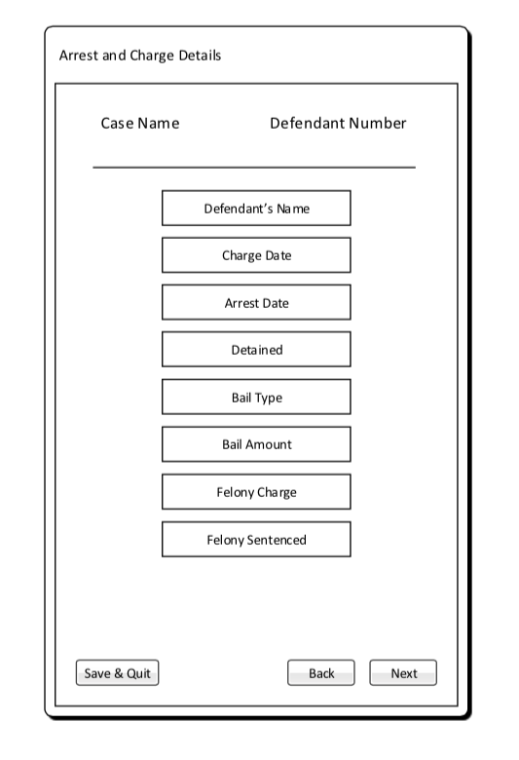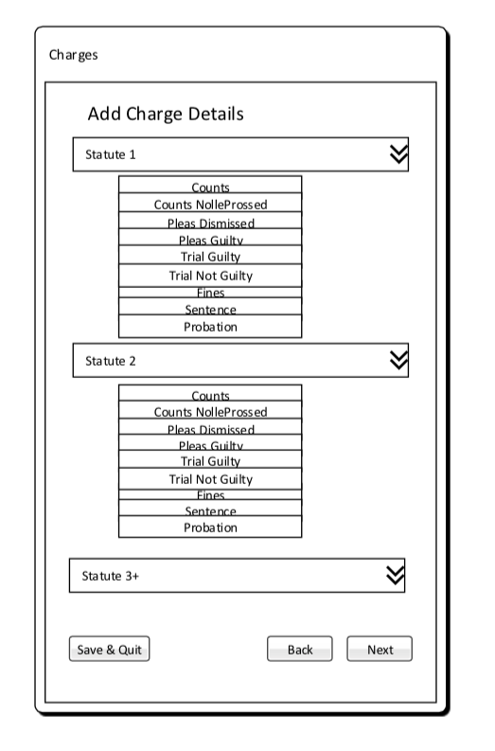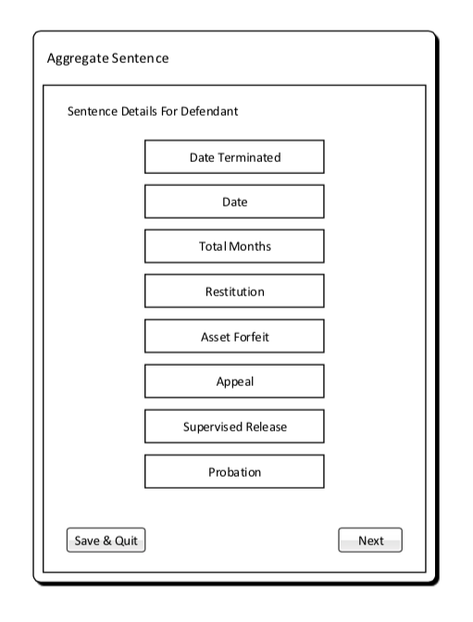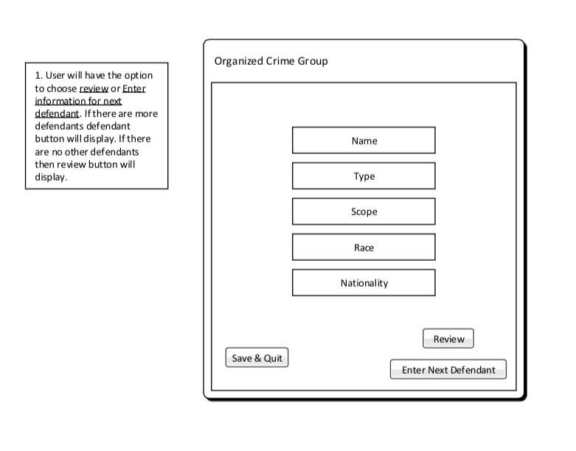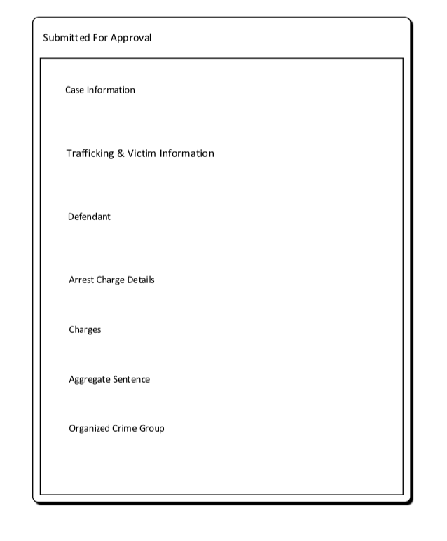

# Glossary of Terms

**Administrator** – Privileged user capable of performing major changes to database.

**Application** – Group of programs designed to supply an end-user with expected functionality.

**CakePHP** – A free, open-source, rapid development framework for PHP.

**Control** **Panel** – An interface specifically designed to allow administrators to easily perform their tasks.

**CRUD –** Create, read, update, delete operations that query database.

**Database** – A structured set of data held in a computer, accessible in various ways.

**Deliverable** – A product, not necessarily finished, related to the project given to the client.

**End-User** – A person or persons who will be using the web application for the specified purpose of our project.

**Foreign Key** – A field in one table that uniquely identifies a row of another table.

**GitHub** – A Web service for software version control.

**Host** – A website on a server accessible over the Internet.

**Milestone** – A point at which project progress can be assessed.

**PHP** – A general-purpose scripting language that is especially suited to server-side web development.

**Primary Key** – Uniquely identifies each record in the table.

**Prototype** – Simulates only a few aspects of, and may be completely different from, the final product.

**TCU** – Texas Christian University

**UML** – Unified Modeling Language; a modeling language designed to provide a standard way to visualize the design of a system.

**Walk-through** – Points during the project where the team describes significant project components with clients and individuals within the team.

**Web Application** – Application that is accessed by visiting a specific URL.